Ahsanullah University of Science & Technology

Department of Computer Science & Engineering


Seba-NGO Management System

Information System Design

&

Software Engineering Lab

CSE-3224

Data Flow Diagram & Use Case Modelling

Quest

Submitted By

# Ashfaq Ali Shafin | 14.01.04.111
# Irtiza Abir | 14.01.04.122
# Abid Hasan Prottoy | 14.01.04.125

Introduction:

This report has covered two essential parts of this project. These are: Data Flow Diagram & Use Case Modelling. Data Flow Diagram is a graphical representation of System’s data and how the process transform data. This is the most common way of documenting the process of current and required System. Use Case Modelling is a set of visual symbols to represent software requirements.

Data Flow Diagram (DFD):

Activity List:

Micro Credit | Education | Administration | Payroll
Customer Request | Customer Request | Content | Pay for Employee
to be assigned in | to be assigned in | Modification
Micro-Credit Project | Education Project | (add/delete/modify)
 |  | Donation Procedure | Employee Salary
 |  |  | Calculation
Feedback of the | Feedback of the | Keeping Track of
Request | Request | Donation
Loan Assignment |  | Task assignment for | Work rate of
 |  | Employee | Employee
Loan Receiving | Admission in | Keeping Track of
 | Program | Employees’ Work

Main Process: Ngo Management System

Sub Process: Micro-Credit, Education, Administration, Payroll

Entity: Customer, Donor, Admin, Employee

Database: Customer_Info, Donor_Info, Admin_Info, Employee_Info, Content, Donation_Info,

Loan_Info, Education_Info, Time_Working, Employee_Salary

1
DFD - Context Level:
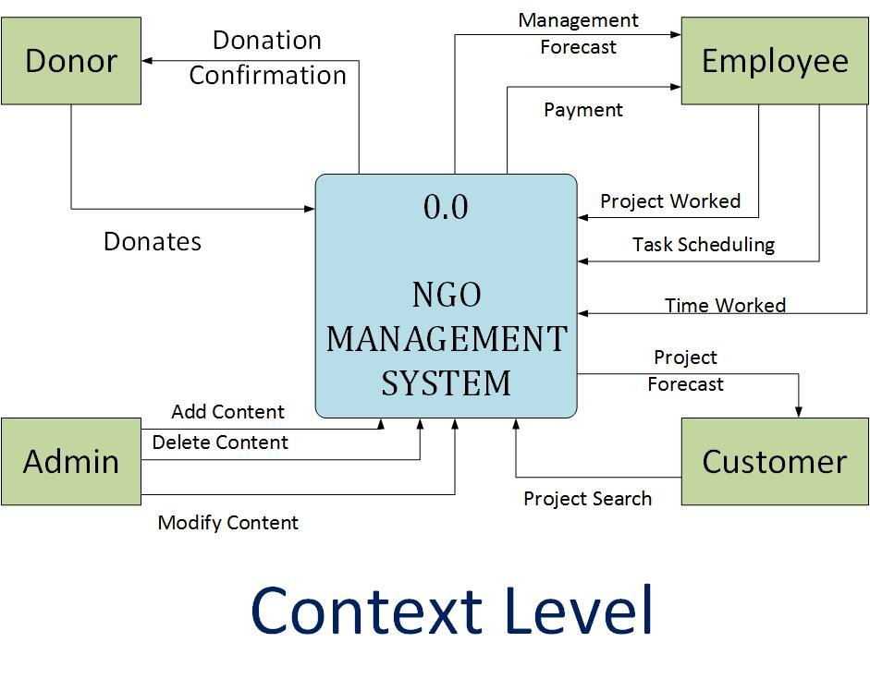

DFD – Level 0:
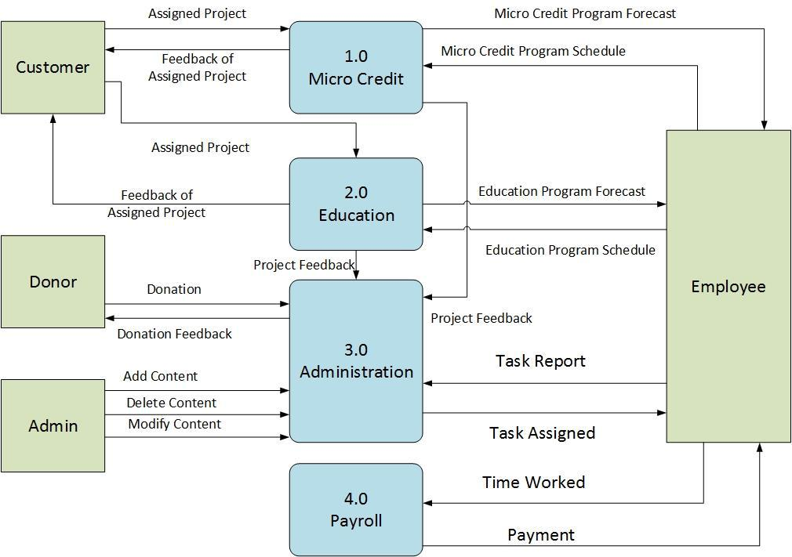

2
DFD - Level 01:
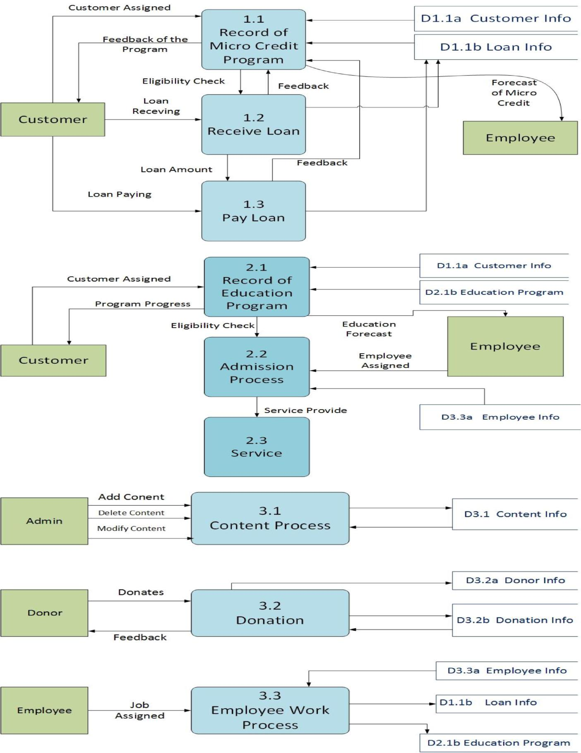

3
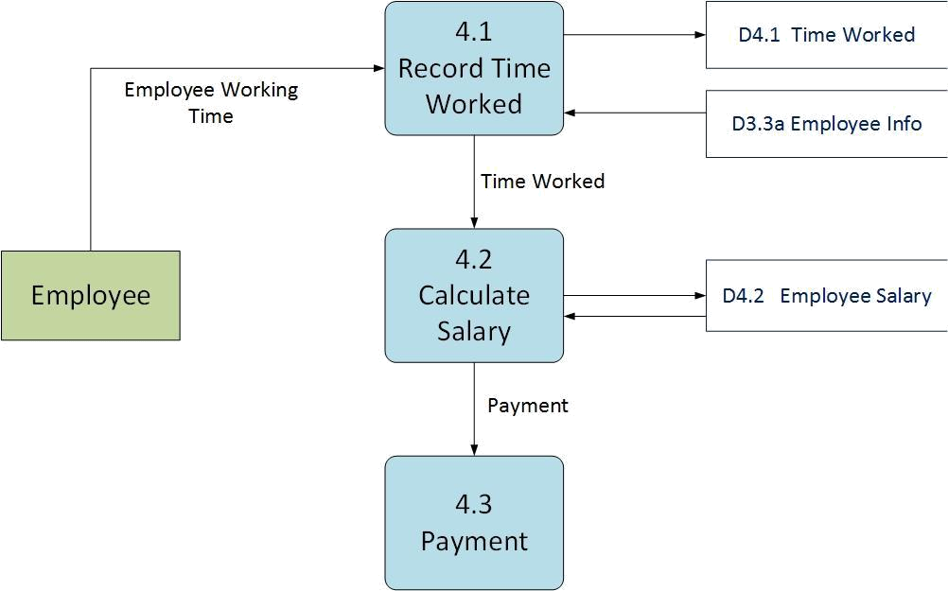

Process Decomposition:

Context Level | Level -0 | Level-1
 | 1.0 Micro-Credit | 1.1 Record Micro-Credit Program
 |  | 1.2 Receive Loan
 |  | 1.3 Pay Loan
 | 2.0 Education | 2.1 Record Education Program
NGO Management |  | 2.2 Admission
System
System |  | 2.3 Service
 | 3.0 Administration | 3.1 Content Process
 |  | 3.2 Donation
 |  | 3.3 Employee Work Process
 | 4.0 Payroll | 4.1 Pay to Employee

4
Use Case Modelling:

Actors:

- Visitor

- Donor

- Admin

- Employee

- Customer

Use Case Diagram:
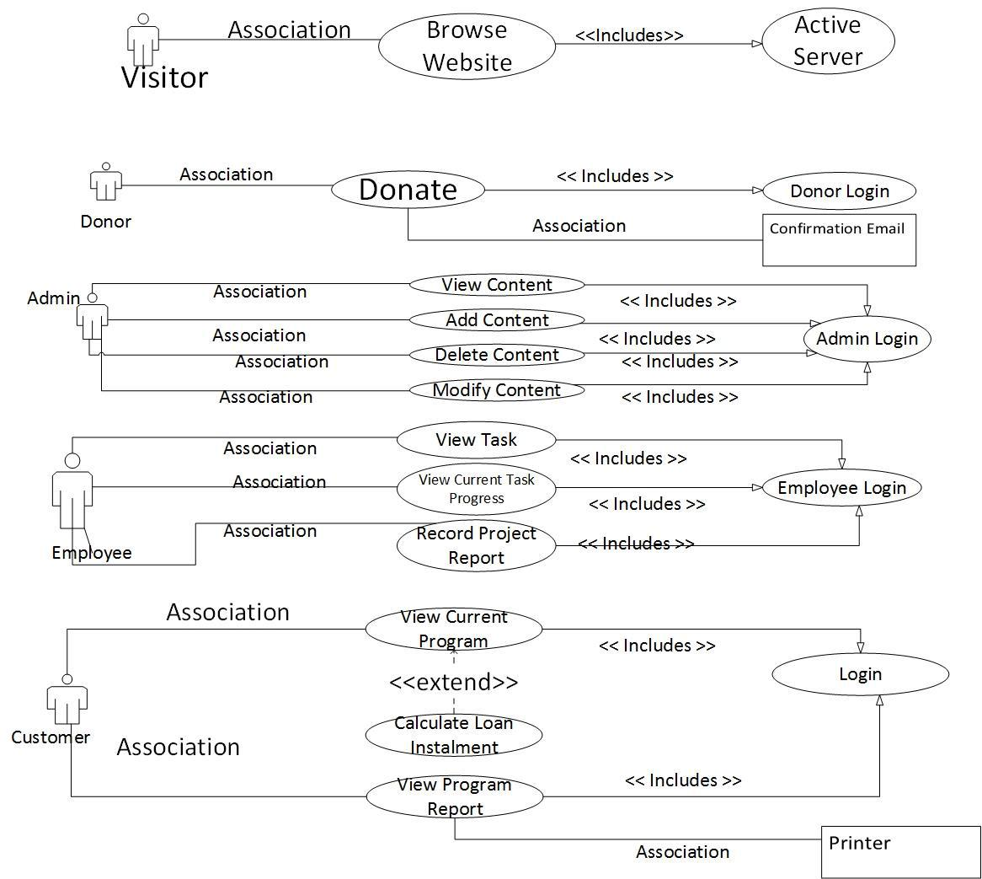

5

Use Case Modelling: Visitor

Association

Visitor

Browse | <<Includes>> | Active
Browse |  | Server
Website |  | Server
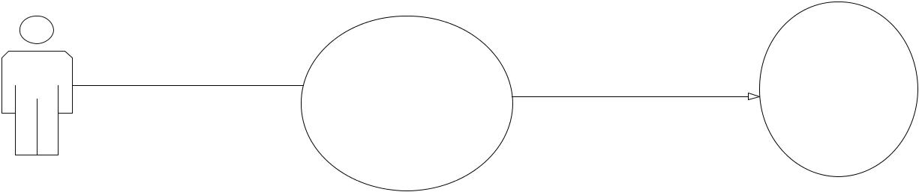
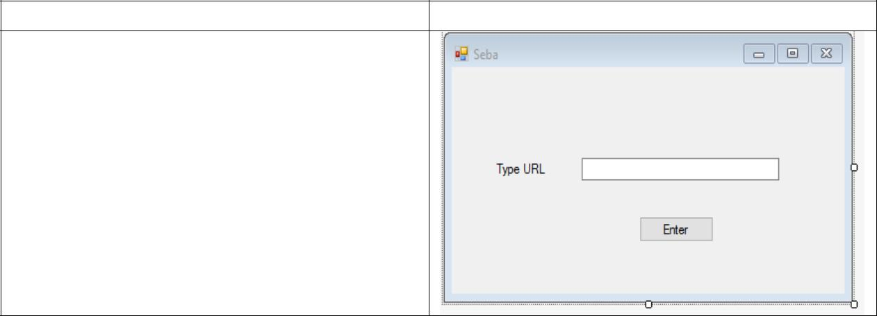

Use Case: Browse Website | GUI

- Actor: Visitor
- Pre-Condition: Active Server

- Primary Path: Type Web Address, Click “Enter” Button

- Alternate Path: Wrong Web Address

Use Case Modelling: Donor
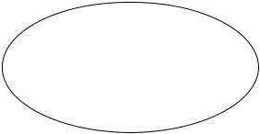
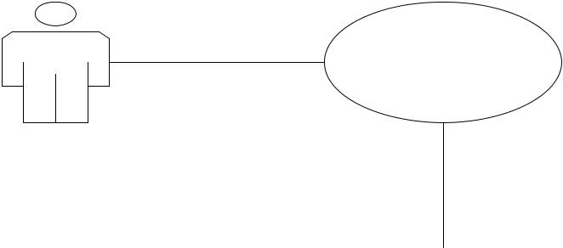

Association

Donate Login
<< Includes >>

Donor

 |  |  | Association |  | Confirmation
 |  |  |  |  | Email
 | Use Case: Donor Login |  |  | GUI
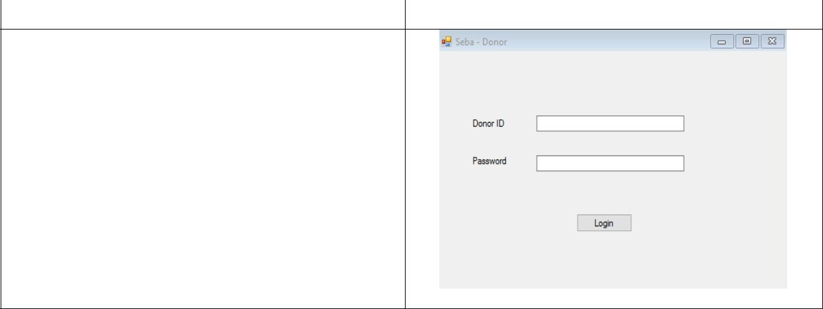
- Actor: System
- Pre-Condition: None

- Primary Path: Insert Donor ID, Insert Password, Click Login

- Alternate Path: Wrong Donor ID, Wrong Password

6

Use Case: Donor Donate | GUI

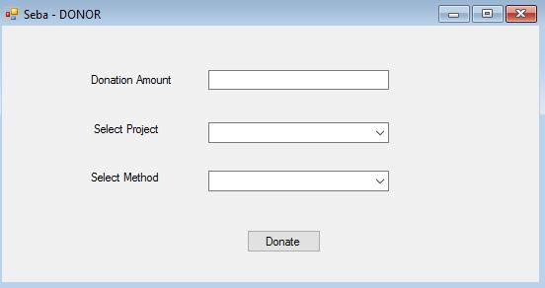
- Actor: Donor
- Pre-Condition: Donor Login

- Primary Path: Writing the amount to be donated, Select Project, Select Method, Click
“Donate” Button

- Alternate Path: Wrong Amount, Wrong Project

Use Case Modelling: Admin
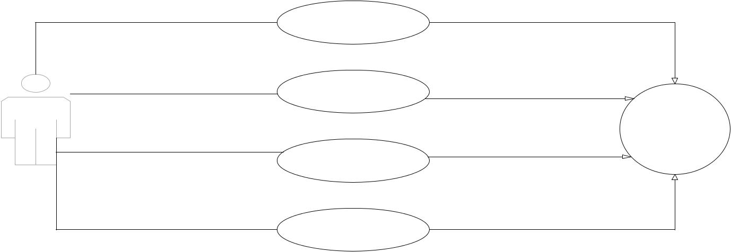

 | View Content | << Includes >>
Association |  | << Includes >>
Association | Add Content
Association |  | << Includes >>
 |  | Admin Login
Association | Delete Content | << Includes >>
Admin
 |  | << Includes >>
 | Modify Content
Association

 | Use Case: Admin Login | GUI
• | Actor : System
• | Pre-condition : None
• | Primary Path :
 | i) enter admin id
 | ii) enter password
• | iii) click “login”
• | Alternate Path:
 | i) wrong id
 | ii) wrong password
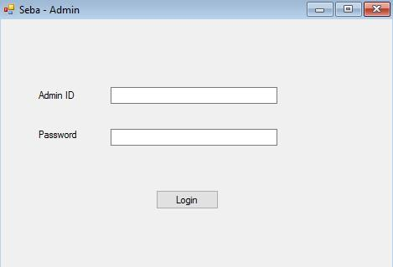

7
 | Use Case: View Content | GUI
• | Actor : Admin
• | Pre-condition : Login
• | Primary Path :
 | i) Select Program
 | ii) Select Project
• | iii) Click “view”
• | Alternate Path:
 | i) Wrong Program
 | ii) Project not Available
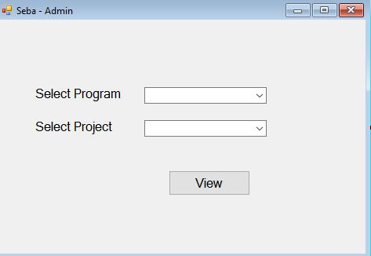

 | Use Case: Add Content | GUI
• Use Case: Add Content
• | Actor : Admin
• | Pre-condition : Login
• | Primary Path :
 | i) Enter Program
 | ii) Enter Project
• | iii) Click “Add Content”
• | Alternate Path:
 | i) Program & Project already
 | saved
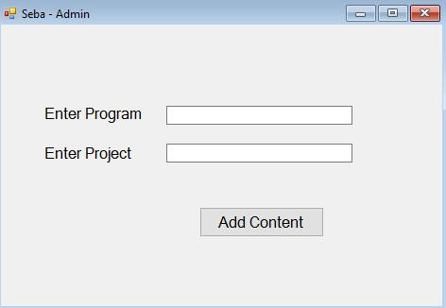

 | Use Case: Delete Content | GUI
• Use case : Delete Content
• | Actor : Admin
• | Pre-condition : Login
• | Primary Path :
 | i) Select Program
 | ii) Select Project
• | iii) Click “Delete Content”
• | Alternate Path:
 | i) Wrong Program
 | ii)Project Not Found
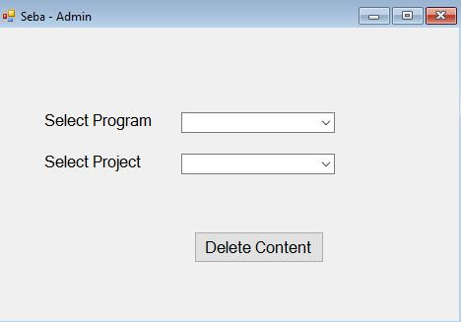

8
 | Use Case: Modify Content | GUI
• Use case : Modify Content
• | Actor : Admin
• | Pre-condition : Login
• | Primary Path :
 | i) Select Program
 | ii) Select Project
 | iii) Modify Program & Modify
asdasdaasProject
 | iv) Click “Modify Content”
• | Alternate Path:
 | i) Wrong Program
 | ii) Project Not Found
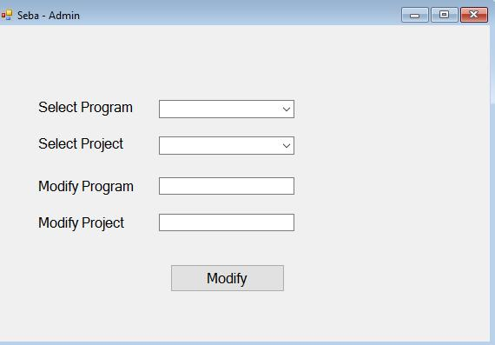

Use Case Modelling: Employee
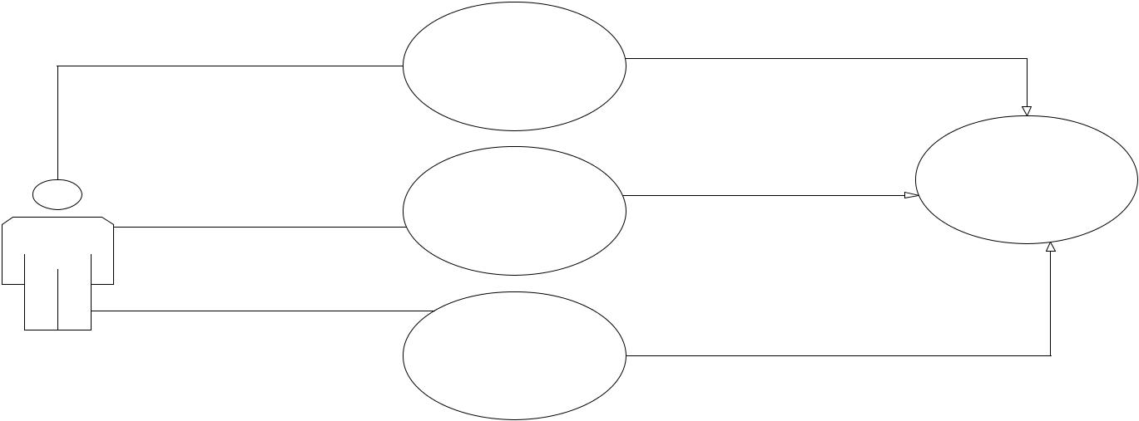
Association

 |  | View Task | << Includes >>
 |  |  | Employee Login
 | Association | View Current Task | << Includes >>
 | Association | Progress | << Includes >>
 | Association | Record Project
Employee |  | Record Project
Employee |  | Report | << Includes >>

 | Use Case: Employee Login |  | GUI
• | Actor : System
• | Pre-condition : None
• | Primary Path :
 | i) Insert ID
 | ii) Insert Password
• | iii) Click “Login”
• | Alternate Path:
 | i) Wrong ID
 | ii)Wrong Password
 |  | 9
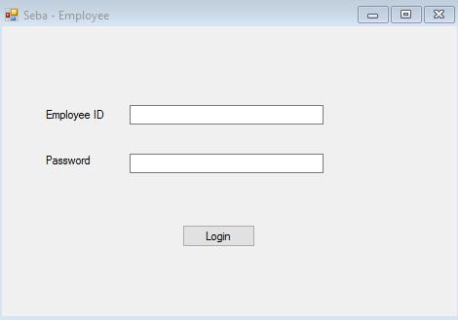
 | Use Case: Employee View | GUI
 | Task
• | Actor : Employee
• | Pre-Condition : Login
• | Primary Path :
 | i) Select Project
 | ii) Select Program
 | iii) Select “View Task” Button
• | Alternate Path:
 | i) Wrong Program/Project
Use case : Employee View Current |  | GUI
 | Task Progress
• | Actor : Employee
• | Pre-Condition : Login
• | Primary Path :
 | i) Select Program
 | ii) Select Project
 | iii) Select “Current Task
sddsdfsdf Progress”
• | Alternate Path:
 | i) Wrong Program/Project
 | Use case : Employee Record | GUI
 | Project Report
• | Actor : Employee
• | Pre-Condition : Login
• | Primary Path :
 | i) Select Program
 | ii) Select Project
 | iii) Type Date
 | iv) Type Project Report
 | v) Select “Save” Button
• | Alternate Path:
 | i) Wrong Program/Project
 | 10
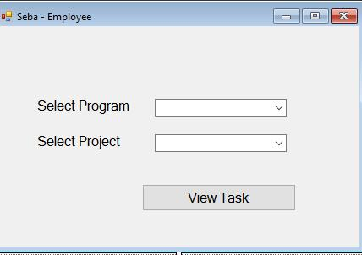
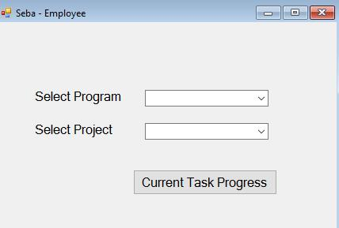
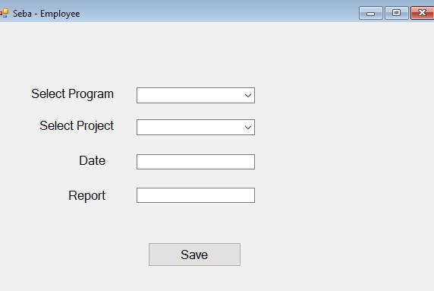
Use Case Modelling: Customer
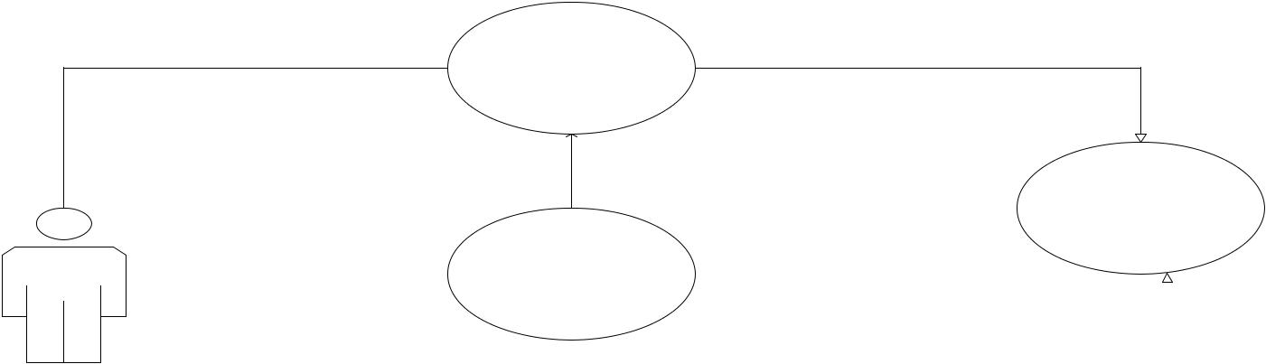

Association

View Current
Progress << Includes >>

 |  |  |  |  |  | <<extend>>
 |  |  |  |  |  |  |  |  |  |  | Login
 |  |  |  |  |  | Calculate Loan
 |  | Customer |  |  |  | Instalment
 | Association |  |  |  |  | View Program |  |  | << Includes >>
 |  |  |  |  |  | Report
 |  |  |  |  |  |  |  |  | Association |  | Printer
 |  |  | Use case : Customer Login |  |  |  |  |  | GUI
 |  | • | Actor : System
 |  | • | Pre-Condition : None
 |  | • | Primary Path :
 |  |  | i) Insert ID
 |  |  | ii) Insert Password
 |  |  | iii) Click “Login Button”
 |  | • | Alternate Path:
 |  |  | i) Wrong ID
 |  |  | ii)Wrong Password
 |  |  | Use Case : View Current Progress |  |  |  |  |  | GUI
 |  | • | Actor : Customer
 |  | • | Pre-Condition : Login
 |  | • | Primary Path :
 |  |  | i) Select Program
 |  |  | ii) Select Project
 |  | • | iii) Select “Current Progress”
 |  | • | Alternate Path:
 |  |  | i) Wrong Program/Project
 |  |  |  |  | 11
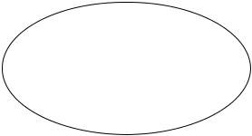
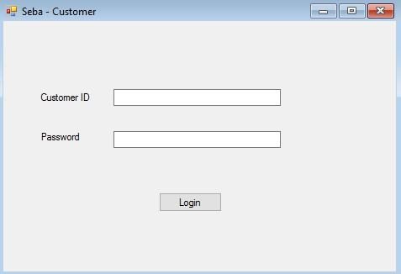
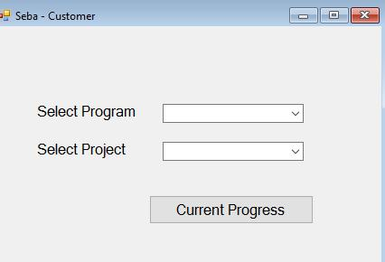

 | Use case : Calculate Loan | GUI
 | Instalment
• | Actor : System
• | Pre-Condition : Login
• | Primary Path :
 | i) Select Program
 | ii) Select Project
 | iii) Select “Loan Information”
• | Alternate Path:
 | i) Wrong Program/Project
 | Use case : Customer View Program | GUI
 | Report
• | Actor : Customer
• | Pre-Condition : Login
• | Primary Path :
 | i) Select Program
 | ii) Select Project
• | iii) Select “View Program Report”
• | Alternate Path:
 | i) Wrong Program/Project
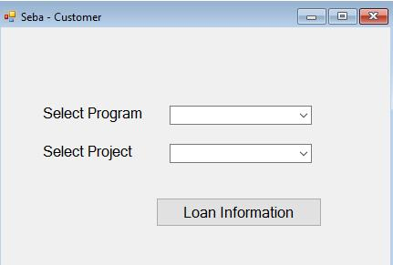
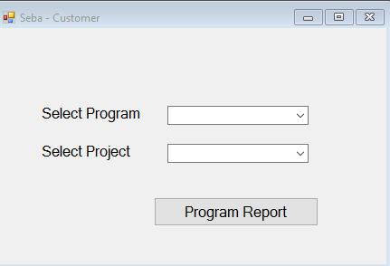

Conclusion:

This concludes the Data Flow Diagram & Use Case Modelling. This report deals with how data are being processed and when they are processed. This also helps to create clear view of usage of this software for different actors for different purposes.

12

